**Screenshots of all Exercise: Create interactive dashboard for sales and profits**

Task 1 create a bar chart that shows customers sales and filter data based on sales with at least $70.

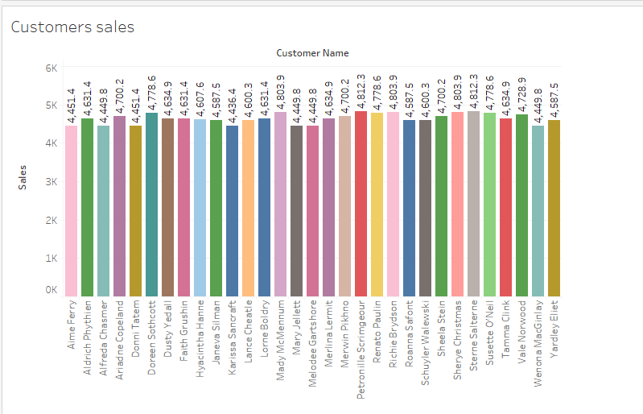

Task 2 create a line chart to show the sales trend from 2019 to 2022.

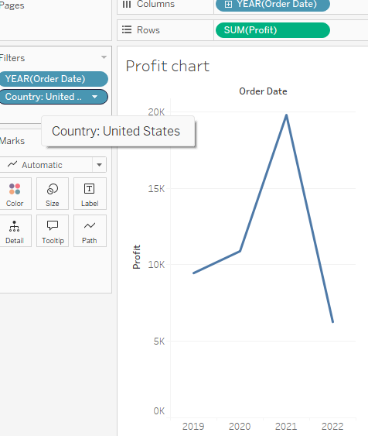

Task 3 create a Bubble chart of sales for all customers. The chart should show the names of all customers. Once you roll over a bubble, the chart should show the name, profit and sale.

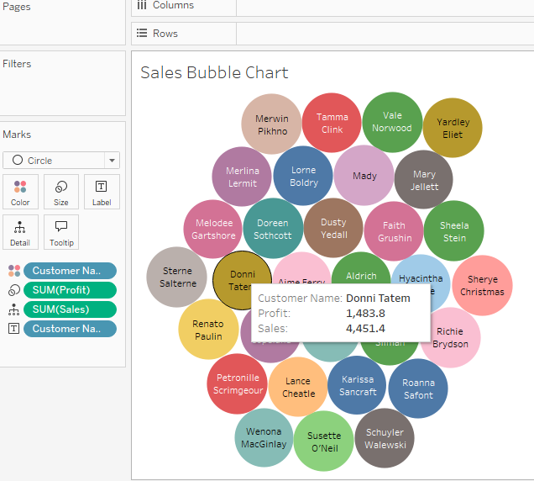

Task 4,

compare the sales of the three different cuisines sold at Little Lemon. Create a Bar chart that shows the sales of the Turkish, Italian and Greek cuisines.

You need to display sales data for 2020, 2021, and 2022 only. Each bar should display the profit of each cuisine.

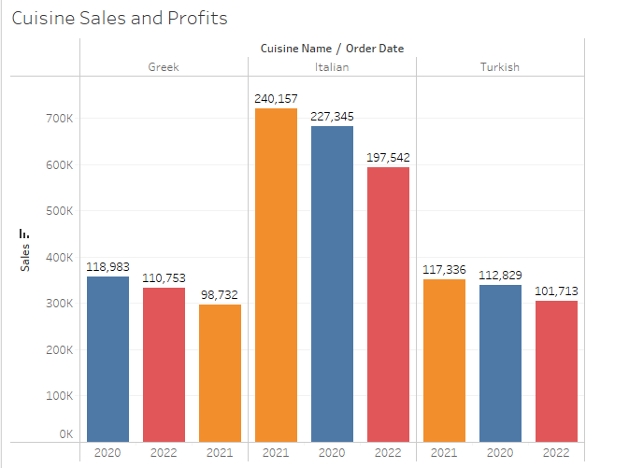

Task 5 create an interactive dashboard that combines the Bar chart called **Customers sales** and the **Sales** Bubble Chart. Once you click a bar, and roll over the related bubble, the name, sales and profit figures should be displayed in the Bubble chart as shown below.

